Test Description:
Verify that "שלחו לי שוב" will send another email confirmation to user +
Verify "חזרה לתהליך ההרשמה" link navigates user to Sign Up page
Test Purpose: Verify that "שלחו לי שוב" will send email confirmation to user about Password Change if he didn't get the first one. And verify "חזרה לתהליך ההרשמה" link navigates user to Sign Up page

Test Run Instructions: <Describe any special instructions needed to execute this test>
Test Run Information:  Tester Name: Ariel  Date of Test: 13/10/2023 | Prerequisites for this test: None
Software Versions:
Application:
Browser: Chrome
Operating System: Win 10 Pro
 | Required Configuration: None
NOTES and RESULTS:

TEST SCRIPT STEPS/RESULTS
STEP | TEST STEP/INPUT | EXPECTED RESULTS | ACTUAL RESULTS |  | PASS/FAIL
Sanity – Functionality Positive – "שלחו לי שוב"
 | Be on Login page  https://my.issta.co.il/login | Site opens | Site opens |  | PASS
 | Click on "שכחתי סיסמא" | Page stays the same,  Password field "הזנת סיסמא" changes to "Phone Number" "טלפון נייד"  Email "כתובת דוא"ל" stays the same | Page stays the same,  Password field "הזנת סיסמא" changes to "Phone Number" "טלפון נייד"  Email "כתובת דוא"ל" stays the same |  | PASS
 | Enter existing account Email such as  Arieldanino98@gmail.com  In email field "כתובת דוא"ל" | No error pop ups | No error pop ups |  | PASS
 | Enter valid phone number linked to account such as  0543215166 | No error pop ups | No error pop ups |  | PASS
 | Click On "שחזור סיסמא" | Navigate to page that confirms your request  And receive a confirmation mail  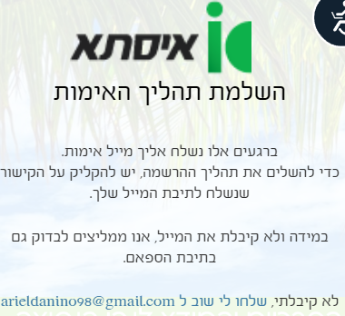 | Navigate to page that confirms your request  And receive a confirmation mail |  | PASS
 | Click on "שלחו לי שוב ל arieldaninio98@gmail.com" | Pop up message  "ברגעים אלו נשלח אליך מייל אימות"  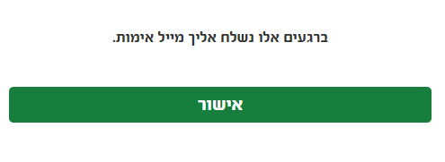 | Pop up message  "ברגעים אלו נשלח אליך מייל אימות" |  | PASS
 | Click on "אישור" | Pop up message closes | Pop up message closes |  | PASS
 | Verify that you received another confirmation email to  Arieldaninio98@gmail.com such as  היי John, כמעט סיימנו.  כדי לאמת את חשבונך ולאפשר שימוש מלא במערכת יש ללחוץ על הקישור הבא:  https://my.issta.co.il//emailverification?sid=F0A38078-7E9C-4A29-90A3-1513D7132CB8 | received | received |  | PASS
 |  | Sanity - GUI testing-"שלחו לי שוב"
1 | Verify that  "שלחו לי שוב ל arieldaninio98@gmail.com" is highlighted as a link, and is clickable | Highlighted and clickable | Highlighted and clickable |  | PASS
2 | Verify that  "חזרה לתהליך ההרשמה" is clickable | clickable | clickable |  | PASS
3 | Verify spelling of feature | Checked | Checked |  | PASS
Sanity – Functionality Positive – חזרה לתהליך הרשמה Feature
 | Be on Login page  https://my.issta.co.il/login | Site opens | Site opens |  | PASS
 | Click on "שכחתי סיסמא" | Page stays the same,  Password field "הזנת סיסמא" changes to "Phone Number" "טלפון נייד"  Email "כתובת דוא"ל" stays the same | Page stays the same,  Password field "הזנת סיסמא" changes to "Phone Number" "טלפון נייד"  Email "כתובת דוא"ל" stays the same |  | PASS
 | Enter existing account Email such as  Arieldanino98@gmail.com  In email field "כתובת דוא"ל" | No error pop ups | No error pop ups |  | PASS
 | Enter valid phone number linked to account such as  0543215166 | No error pop ups | No error pop ups |  | PASS
 | Click On "שחזור סיסמא" | Navigate to page that confirms your request  And receive a confirmation mail  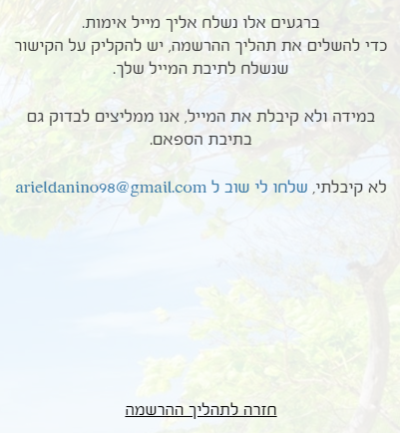 | Navigate to page that confirms your request  And receive a confirmation mail |  | PASS
 | Click on "חזרה לתהליך הרשמה" | Navigates back to sign up page  https://my.issta.co.il/signup | Navigate back to sign up page  https://my.issta.co.il/signup |  | PASS

